PHASE B

UML Diagram and Interfaces

**UML diagram**

Please refer the UML diagram attached separately.

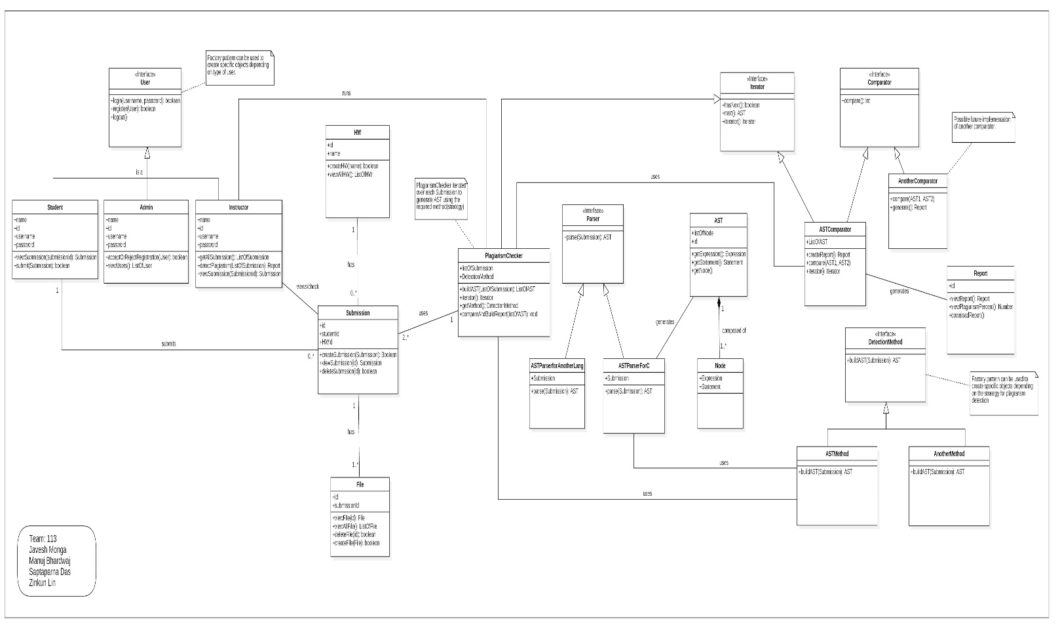

**Interfaces**

These are the interfaces that we will implement:

1. Comparator
2. DetectionMethod
3. Iterator
4. Parser
5. User

**Design Pattern Used**

These are the design patterns to be used:

1. Factory pattern: This design pattern is used to create various objects of specific type of users.
2. Strategy pattern: This design pattern allows us to encapsulate the algorithm used for detecting plagiarism.